**The process of conducting Aviation English interview**

**Part One: Interview (9 to 10 minutes)**

**1-1 Introduction and warm up:**

In this section, while introducing himself, the interlocutor (Second Rater) tries to create an intimate atmosphere away from tension by asking daily questions. The goal of this part of the interview is to calm the test taker and prepare him/her for the main interview questions. It shall be noted that in this part of the interview, the participant's answers **are not used** to determine the test taker`s level due to the possibility of being affected by the stress of the test or memorizing sentences already practiced by the test taker. Considering the purpose of this part of the interview (to create a calm and intimate atmosphere in the interview), the duration of this part is between **three** to **five** minutes.

Examples of questions in this section include the following.

* Have you always lived in Tehran?
* What type of degree do you hold?
* How did you come to the test center?
* What airport do you work for and how many years of experience do you have?
* Can you describe your current role and the main responsibilities you have in your position?

**1-2 Discussion:**

In this part, the assessor will use the main interview questions. The questions will be such that they include different grammatical structures, the range of different words from different fields of aviation so that the level of the participant's language can be checked better. Also, in order to check better and prevent the participant from using pre-prepared answers, the assessor will use the Probing method. This means that the assessor will ask new questions outside of the previously prepared questions in order to elicit ratable speech and make a correct judgment about the candidate's actual level.

This section comprises two topics for levels 4 and 5 or three topics for level 6. Each topic includes three predefined questions along with three optional probing questions in a semi-structured test format. The arrangement of questions shall follow a progression from easy to difficult. Specifically, the questions within the first topic are designed to be easier than those in the second topic, and similarly, the questions in the second topic are intended to be easier than those in the third.

Examples of questions in this section include the following:

**First topic: Adverse weather**

1. Define adverse weather in aviation.
   * Probing question: What are the primary challenges for controllers during these conditions?
2. In the event of approaching severe weather, what steps shall an air traffic controller take to ensure the safety of aircraft within their airspace?
   * Probing question: what would you do as an aerodrome tower controller when you don’t find runway condition suitable for landing or take-off due to some weather phenomenon?
3. As a Tower controller, you receive a report of wind sheer on final approach of the active runway. What would you do? explain
   * Probing question: if a CB is reported on take off path, what would be your reaction?

**Second topic: structural damage**

1. Define what structural damage is?
   * Probing question: What factors contribute to structural damage?
2. What would you do as an air traffic controller receiving the report of structural damage?

* Probing question: Have you ever experienced or heard about an aircraft reporting a structural damage?

1. What is the procedure in your airport regarding a report of an incident on apron in which a truck hits an aircraft causing a structural damage?

* Probing question: How can air traffic control systems contribute to preventing structural damage on the aerodrome layout?

**Part Two: Radio-telephony Role play (5 to 7 minutes)**

In the second part, the test taker will assume the role of a pilot or an air traffic controller in a role-play scenario. Prior to the scenario, a Task Card (shown below) will be presented on the screen, offering crucial information and guidance to navigate each situation. The test taker takes one minute to review and prepare; the card will remain visible. Once the task commences, the test taker will directly communicate with the assessor, who takes on the opposite role. Test taker shall respond to each message using standard ICAO phraseology when applicable or plain English.

|  |
| --- |
| **Sample Role-Play**  **Report position, ask to land**  **Test taker's card (pilot)**    **Position 2 NM, tell the controller you see a car in runway**  **ATC**  **Problem:**  **Runway Incursion and Bird Strike**  **Ask to cancel landing and come back to land**  **ATC**  **Your call sign: ABC493**  **Type: B737**  **OIII to OIAD Altitude: 2500 ft**  **Position: 12 NM final**  **RWY: 14L**  **Declare emergency due to bird strike to left engine**  **ATC**  **ATC**  **Ask for firefighting services** |

**Pilot: Report position, ask to land**

**Controller: ABC Roger, clear to land RWY 14L, wind 120 degrees 12 knots**

**Pilot: Readback the instruction**

**Pilot: Position 2 NM, tell the controller you see a car in runway**

**Controller: ABC493 roger**

**Controller to Vehicle: vacate active RWY immediately.**

**Pilot: Ask to cancel landing and come back to land**

**Controller: ABC493 Roger Report left downwind**

**Pilot: Declare emergency due to bird strike to left engine**

**Controller: Understood Bird strike on left engine, priority NO.1 report final RWY 14L**

**Pilot: Ask for firefighting services**

**Part Three: Description of aviation images (4 to 5 minutes)**

In this section, the test taker is presented with two pictures depicting unusual situations about airplanes and flight operations. The images are shown one by one, allowing the test taker 30 seconds for careful observation and the option to write down key points (for voluntary use only and not for evaluation). After the 30-second period, the test taker is prompted to describe the first picture, followed by a similar process for the second picture.

Throughout the description of the pictures (one to two minutes), the assessor refrains from interrupting the test taker's conversation. Following the picture descriptions, the assessor may pose additional questions about the images, such as making comparisons, evaluating the severity of each situation, or seeking the test taker's opinion on the reasons behind the depicted accidents or incidents.

Here are two examples of images used in the test.

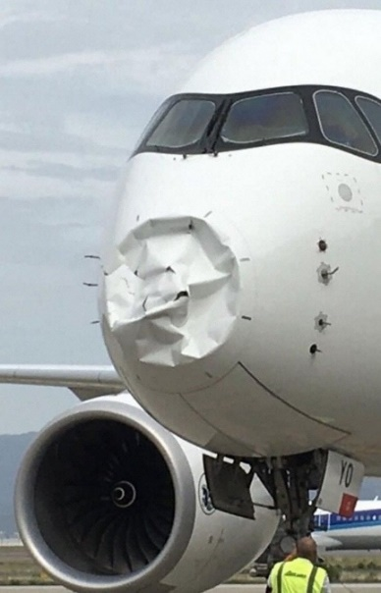

And the second one:

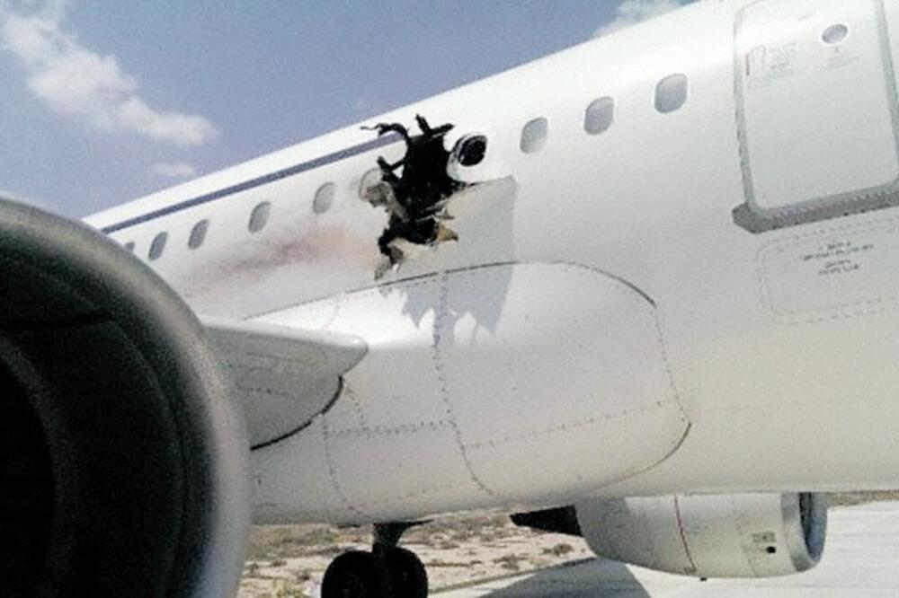

Note: To ensure consistency and fairness in the process, the second assessor is obligated to use the specified test task instructions in the question kit to guide the test taker in explaining this section of the test. Such as:

1. Which situation would you consider to be more serious? Why?

2. What could have caused the incident in each situation?

3. What effect would each situation have on operations?

4. What shall happen next in each situation?

**Part Four: Listening Comprehension (7 to 8 minutes)**

This part has two sections. The first section is different for pilots and air traffic controllers. But the second section is the same.

**Section One (Pilots only)**: In the first section, the test taker listens to an **ATIS broadcast** and is required to report all the key information. If the test taker misses any details during the initial attempt, they are permitted to listen to the ATIS again, not more than twice. Note-taking during the listening process is highly recommended. Example:



**Section One (ATCOs only)**: In the first part, the test taker listens to an **ATC route clearance** provided by a controller. Subsequently, the test taker listens to the pilot's readback and shall determine its accuracy. If any mistakes are noted, the test taker shall be capable of identifying and reporting them. In case of missing any details during the initial attempt, the test taker may request repetition, not exceeding twice. It is highly recommended to take notes during the listening process. Example:



**Section Two (ATCOs and Pilots):**

Now, the test taker listens to a non-routine transmission between a pilot and an air traffic controller. Then, the test taker needs to provide a spoken report of the non-routine event(s) from the recording. He/she shall try to give as many details as possible in their report. It is highly recommended that the test taker takes notes during the listening. If he/she misses anything at the first attempt, the test taker can listen again. It's important to note that he/she cannot hear the recording a third time. Example:

